[Title in TNRoman and Bold No. 14 in English and Spanish]

Surname, Name 1st Author*ª, Surname, Name 1st Co-author^{b}, Surname, Name 2nd Co-author^{c} and Surname, Name 3rd Co-author^{d} [No.12 TNRoman]

ª Affiliation institution, Researcher ID, ORC ID, SNI-CONAHCYT ID or CVU PNPC [No.10 TNRoman]
^{b} Affiliation institution, Researcher ID, ORC ID, SNI-CONAHCYT ID or CVU PNPC [No.10 TNRoman]
^{c} Affiliation institution, Researcher ID, ORC ID, SNI-CONAHCYT ID or CVU PNPC [No.10 TNRoman]
^{d} Affiliation institution, Researcher ID, ORC ID, SNI-CONAHCYT ID or CVU PNPC [No.10 TNRoman]

CONAHCYT classification:
https://marvid.org/area-i.php [No.10 TNRoman]
Area:
Field:
Discipline:
Subdiscipline:
DOI: https://doi.org/
Article History:
Received: [Use Only ECORFAN]
Accepted: [Use Only ECORFAN]

* [example@example.org]

Graphical abstract [In English]

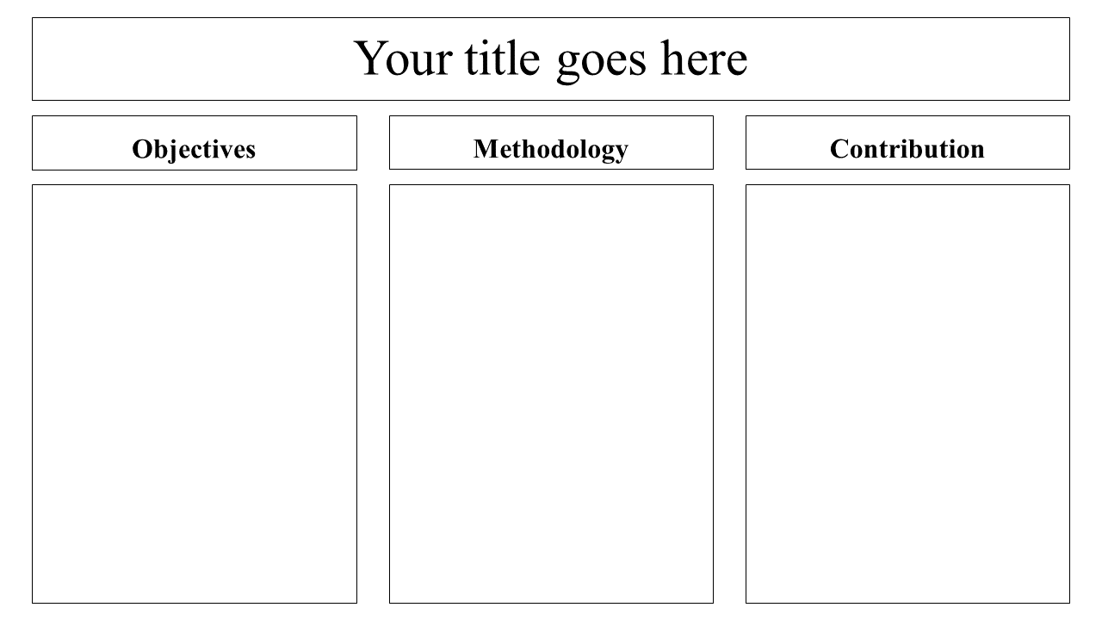

Authors must provide an original image that clearly represents the article described in the article. Graphical abstracts should be submitted as a separate file. Please note that, as well as each article must be unique.

Image size: provide an image with a minimum of 1200 x 500 pixels [width x height] using a minimum resolution of 200 dpi.

Font: TNRoman with a sufficiently large font size, as the image will be reduced in size to fit the table of contents in a 250-pixel high window.

File type: the file types are MS Office files.

No additional text, outline or synopsis should be included. Any text or captions must be part of the image file. Do not use unnecessary white space or a "graphic abstract" header within the image file.

Keywords [In English]
Indicate 3 keywords in TNRoman and Bold No. 10
Graphical abstract [In Spanish]

Authors must provide an original image that clearly represents the article described in the article. Graphical abstracts should be submitted as a separate file. Please note that, as well as each article must be unique.

Image size: provide an image with a minimum of 1200 x 500 pixels [width x height] using a minimum resolution of 200 dpi.

Font: TNRoman with a sufficiently large font size, as the image will be reduced in size to fit the table of contents in a 250-pixel high window.

File type: the file types are MS Office files.

No additional text, outline or synopsis should be included. Any text or captions must be part of the image file. Do not use unnecessary white space or a "graphic abstract" header within the image file.

Keywords [In Spanish]
Indicate 3 keywords in TNRoman and Bold No. 10

Citation: Surname, Name 1st Author, Surname, Name 1st Co-author, Surname, Name 2nd Co-author and Surname, Name 3rd Co-author. Article Title. ECORFAN Journal-Mexico. Year. V-N: Pages [TN Roman No.10].

ISSN XXXX-XXXX/© 2009 The Author[s]. Published by ECORFAN-Mexico, S.C. for its Holding X on behalf of Journal X. This is an open access article under the CC BY-NC-ND license [http://creativecommons.org/licenses/by-nc-nd/4.0/]

Peer Review under the responsibility of the Scientific Committee MARVID®- in contribution to the scientific, technological and innovation Peer Review Process by training Human Resources for the continuity in the Critical Analysis of International Research.

Introduction

Text in TNRoman No.12, single space.

General explanation of the subject and explain why it is important.

What is your added value with respect to other techniques?

Clearly focus each of its features.

Clearly explain the problem to be solved and the central hypothesis.

Explanation of sections Article.

Development of headings and subheadings of the article with subsequent numbers

[Title No.12 in TNRoman, single spaced and bold]

Products in development No.12 TNRoman, single spaced.

Including figures and tables-Editable

In the article content any table and figure should be editable formats that can change size, type and number of letter, for the purposes of edition, these must be high quality, not pixelated and should be noticeable even reducing image scale.

[Indicating the title at the bottom with No.10 and Times New Roman Bold]

Box
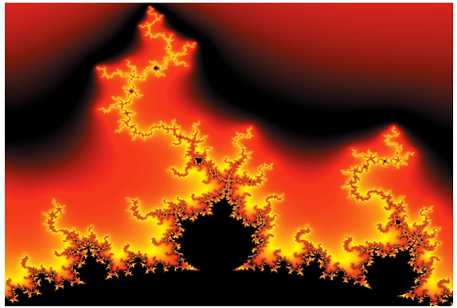

Figure 1
Title [Should not be images-everything must be editable]
Source [in italic]

Box
Table 1
Title [Should not be images-everything must be editable]

Source [in italic]

Each article shall present separately in 2 folders: a) Figures and b) Tables in .JPG format, indicating the number and sequential Bold Title.

For the use of equations, noted as follows:

$Y_{ij}=α+ \sum_{h=1}^{r}{β_{h}X_{hij}}+u_{j}+e_{ij}$ [1]

Must be editable and number aligned on the right side.

Methodology

Develop give the meaning of the variables in linear writing and important is the comparison of the used criteria.

Results

The results shall be by section of the article.

Conclusions

Clearly explain the results and possibilities of improvement.

Annexes

Tables and adequate sources.

Declarations

Conflict of interest

The authors declare no interest conflict. They have no known competing financial interests or personal relationships that could have appeared to influence the article reported in this article.

Author contribution

Specify the contribution of each researcher in each of the points developed in this research.

Availability of data and materials

Indicate the availability of the data obtained in this research.

Funding

Indicate if the research received some financing.

Acknowledgements

Indicate if they were financed by any institution, University or company.

Abbreviations

List abbreviations in alphabetical order.

References

Use APA system. Should not be numbered, nor with bullets, however if necessary numbering will be because reference or mention is made somewhere in the Article.

Use the Roman alphabet, all references you have used should be in Roman alphabet, even if you have cited an article, book in any of the official languages of the United Nations [English, French, German, Chinese, Russian, Portuguese, Italian, Spanish, Arabic], you should write the reference in Roman alphabet and not in any of the official languages.

Citations are classified the following categories:

Antecedents. The citation is due to previously published research and orients the citing document within a particular scholarly area.

Basics. The citation is intended to report data sets, methods, concepts and ideas on which the authors of the citing document base their work.

Supports. The citing article reports similar results. It may also refer to similarities in methodology or, in some cases, to the reproduction of results.

Differences. The citing document reports by means of a citation that it has obtained different results to those obtained in the cited document. This may also refer to differences in methodology or differences in sample sizes that affect the results.

Discussions. The citing article cites another study because it is providing a more detailed discussion of the subject matter.

The URL of the resource is activated in the DOI or in the title of the resource.

Example

Mandelbrot, B. B. [2020]. Negative dimensions and Hölders, multifractals and their Hölder spectra, and the role of lateral preasymptotics in science.Journal of Fourier Analysis and Applications Special. 409-432. DOI: https://doi.org/10.1201/9780429332838

Intellectual Property Requirements for editing:

Authentic Signature in Color of Originality Format Author and Coauthors.
Authentic Signature in Color of the Acceptance Format of Author and Coauthors.
Authentic Signature in blue color of the Conflict of Interest Format of Author and Co-authors.

