[Title in TNRoman and Bold No. 14 in English and Spanish]

CONAHCYT classification: https://marvid.org/research_areas.php [No.10 TNRoman]
Area:
Field:
Discipline:
Subdiscipline:
DOI: https://doi.org/

Key Proceeding:

Explain the following aspects:

-What are the main contributions to generating Science and Technology written in this research?
-What are the key aspects to be understood in order to apply to the generation of universal knowledge?
-Outline the main conclusions of the research.
-How many authors have CONAHCYT grants? How many authors have PRODEP grants, and how many are from external sources?
-How many citations did the authors of the work generate in the last year?
-From which institutions do they originate?
State Public Institutions
State Public Institutions with Solidarity Support
Technological and Polytechnic Universities
Universities Intercultural
Private Institutions
-Which keywords are the most used?

Abstract [In English]
Must contain up to 150 words

Graphical abstract [In English]

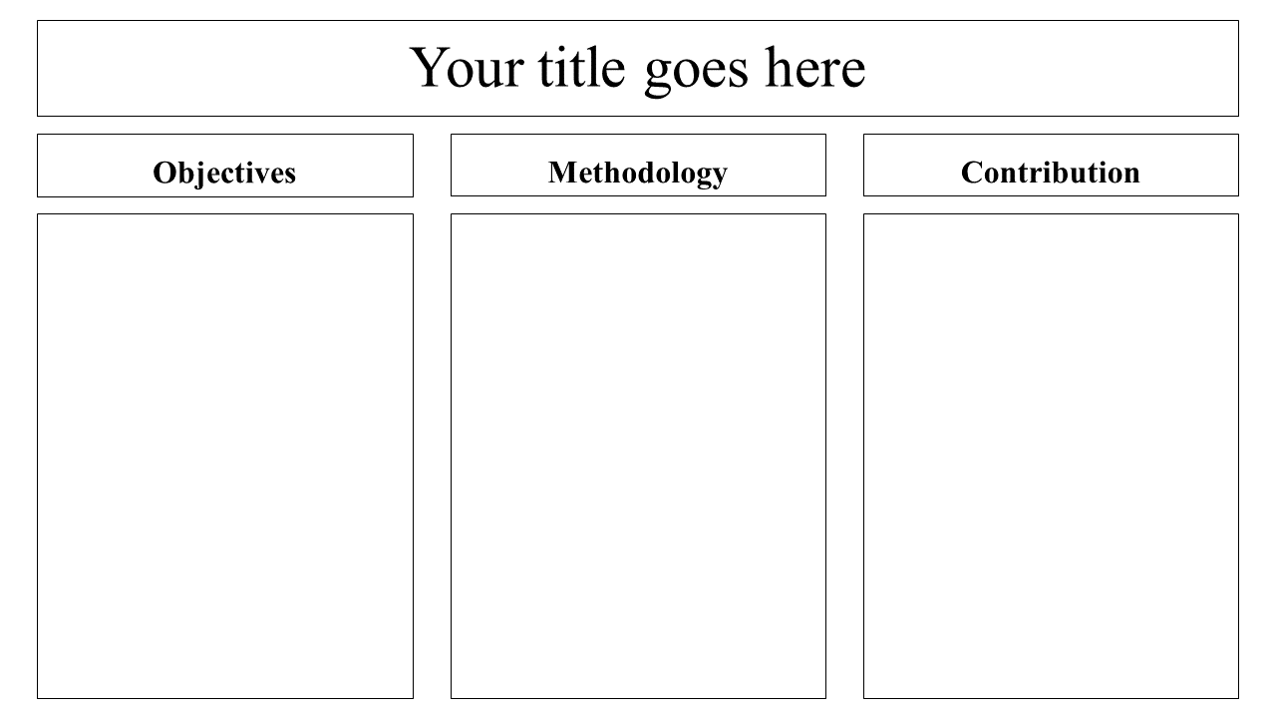

Authors must provide an original image that clearly represents the work described in the chapter. Graphical abstracts should be submitted as a separate file. Please note that, as well as each article must be unique.File type: the file types are MS Office files.No additional text, outline or synopsis should be included. Any text or captions must be part of the image file. Do not use unnecessary white space or a "graphic abstract" header within the image file.

Keywords [In English]
Indicate 3 keywords in TNRoman and Bold No. 12

Abstract [In Spanish].
Must contain up to 150 words

Graphical abstract [In Spanish]

Authors must provide an original image that clearly represents the work described in the book. Graphical abstracts should be submitted as a separate file. Please note that, as well as each article must be unique.File type: the file types are MS Office files.No additional text, outline or synopsis should be included. Any text or captions must be part of the image file. Do not use unnecessary white space or a "graphic abstract" header within the image file.

Keywords [In Spanish]
Indicate 3 keywords in TNRoman and Bold No. 12

Introduction

Text in TNRoman No.12, single space.

General explanation of the subject and explain why it is important.

What is your added value with respect to other techniques?

Clearly focus each of its features

Clearly explain the problem to be solved and the central hypothesis.

Explanation of sections Chapter.

Development of headings and subheadings of the chapter with subsequent numbers

Products in development No.12 TNRoman, single spaced.

Including figures and tables-Editable

In the Chapter content any figure and table should be editable formats that can change size, type and number of letters, for the purposes of edition, these must be high quality, not pixelated and should be noticeable even reducing image scale.

[Indicating the title at the top with No.12 and TNRoman Bold]

Box
Table 1
Title [Should not be images-everything must be editable]

Source [in italic]

Box
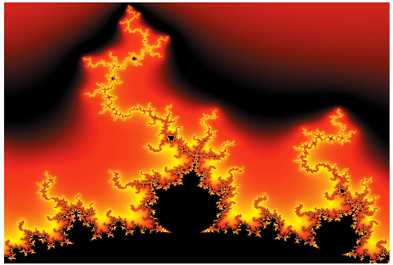

Figure 1
Title [Should not be images-everything must be editable]
Source [in italic]

The maximum number of Boxes is 10 items

For the use of equations, noted as follows:

$\int_{\lim^{-1}}^{\lim^{1}}{=}$ $\int{\frac{\lim^{1}}{\lim^{-1} }} =$ ${\left[\frac{1 (-1)}{lim}\right]}^{2}$ = $\frac{{(0)}^{2}}{lim}$ = $\sqrt{lim}$ = $0 = 0 → ∝$ [1]

Must be editable and number aligned on the right side.

Methodology

Develop give the meaning of the variables in linear writing and important is the comparison of the used criteria.

Results

The results shall be by section of the chapter.

Conclusions

Clearly explain the results and possibilities of improvement.

Annexes

Tables and adequate sources.

The international standard is 7 pages minimum and 14 pages maximum.

Declarations

Conflict of interest

The authors declare no interest conflict. They have no known competing financial interests or personal relationships that could have appeared to influence in this chapter.

Author contribution

Specify the contribution of each researcher in each of the points developed in this research.

Prot-
Benoit-Pauleter, Gerard: Contributed to the project idea, research method and technique.

Availability of data and materials

Indicate the availability of the data obtained in this research.

Abbreviations

List abbreviations in alphabetical order.
ANN | Artificial Neural Network
References

Use APA system. Should not be numbered, nor with bullets, however if necessary numbering will be because reference or mention is made somewhere in the chapter.

Use the Roman alphabet, all references you have used should be in Roman alphabet, even if you have cited a chapter, book in any of the official languages of the United Nations [English, French, German, Chinese, Russian, Portuguese, Italian, Spanish, Arabic], you should write the reference in Roman alphabet and not in any of the official languages.

Citations are classified the following categories:

Antecedents. The citation is due to previously published research and orients the citing document within a particular scholarly area.

Basics. The citation is intended to report data sets, methods, concepts and ideas on which the authors of the citing document base their work.

Supports. The citing article reports similar results. It may also refer to similarities in methodology or, in some cases, to the reproduction of results.

Differences. The citing document reports by means of a citation that it has obtained different results to those obtained in the cited document. This may also refer to differences in methodology or differences in sample sizes that affect the results.

Discussions. The citing article cites another study because it is providing a more detailed discussion of the subject matter.

The URL of the resource is activated in the DOI or in the title of the resource.

Prot-
Mandelbrot, B. B. [2020]. Negative dimensions and Hölders, multifractals and their Hölder spectra, and the role of lateral preasymptotics in science.Journal of Fourier Analysis and Applications Special. 409-432.

