[Title in TNRoman and Bold No. 14 in English and Spanish]

Surname, Name 1st Author*ª, Surname, Name 1st Co-author^{b}, Surname, Name 2nd Co-author^{c} and Surname, Name 3rd Co-author^{d} [No.12 TNRoman]

ª Affiliation institution, Researcher ID, ORC ID, SNI-CONAHCYT ID or CVU PNPC [No.10 TNRoman]
^{b} Affiliation institution, Researcher ID, ORC ID, SNI-CONAHCYT ID or CVU PNPC [No.10 TNRoman]
^{c} Affiliation institution, Researcher ID, ORC ID, SNI-CONAHCYT ID or CVU PNPC [No.10 TNRoman]
^{d} Affiliation institution, Researcher ID, ORC ID, SNI-CONAHCYT ID or CVU PNPC [No.10 TNRoman]

Abstract [In English]
Must contain up to 150 words
Graphical abstract [In English]

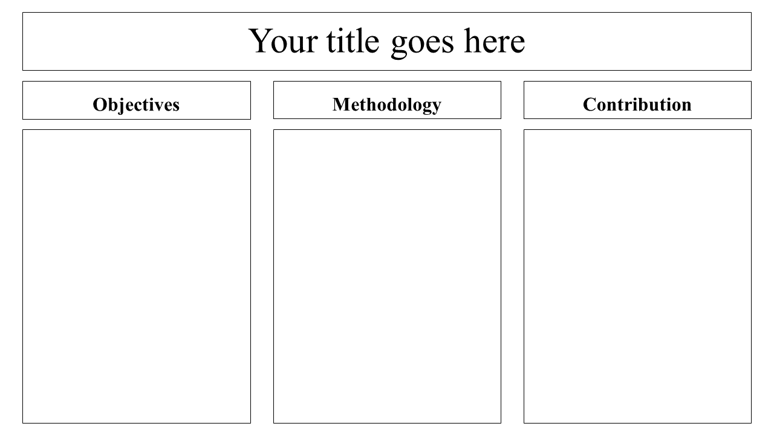

Authors must provide an original image that clearly represents the article described in the article. Graphical abstracts should be submitted as a separate file. Please note that, as well as each article must be unique. File type: the file types are MS Office files.No additional text, outline or synopsis should be included. Any text or captions must be part of the image file. Do not use unnecessary white space or a "graphic abstract" header within the image file.

Keywords [In English]
Indicate 3 keywords in TNRoman and Bold No. 10

List References

Use APA system. Should not be numbered, nor with bullets, however if necessary numbering will be because reference or mention is made somewhere in the Article.

